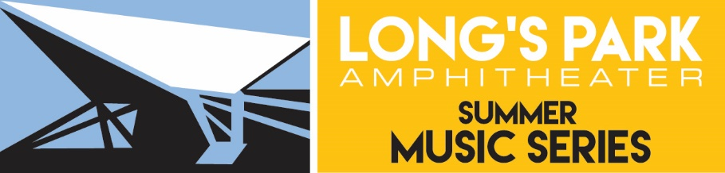

Sponsorship Opportunities

The Summer Music Series is regarded as a top musical entertainment destination in one of the best outdoor venues in Central Pennsylvania. These FREE concerts are made possible through the generosity of individuals and corporate partners. Proceeds from the Long’s Park Art Festival are the other important component to our funding process.

Sponsorship Form

Name:_______________________________________________________________________

Title:________________________________________________________________________

Company:____________________________________________________________________

Address:_____________________________________________________________________

City, State, Zip:________________________________________________________________

Phone:______________________________________________________________________

Email:_______________________________________________________________________

After completing this form, please include a check made payable to Long’s Park Amphitheater Foundation. The amount enclosed is ___________________.

Sponsor Signature:____________________________________________________________

Please return to: Long’s Park Amphitheater Foundation
Attention: Kathy Hainley, Foundation Executive Assistant
313 West Liberty Street, Suite 235
Lancaster, PA 17603

Summer Music Series Donor Benefits

We would like to sponsor the Long’s Park Summer Music Series at the following level:

☐ Level One - $500
On-stage mention at one selected concert
☐ Level Two - $1,500
On-stage mention at three selected concerts
☐ Level Three - $2,500
On-stage mention at three selected concerts
Physical presence with on-site tent
Hand-out promotional items at concerts
Digital billboard truck media promotion at each concert
☐ Level Four - $5,000
On-stage speaking
Physical presence with on-site tent
Hand-out promotional items at concerts
Digital billboard truck media promotion at each concert
Company listing on longspark.org
Use of pavilion for corporate event
Preferred parking
☐ Level Five - $10,000
On-stage speaking
Physical presence with on-site tent
Hand-out promotional items at concerts
Use of foundation appellation and logo to reinforce commitment to the community
Digital billboard truck media promotion at each concert
Company listing on longspark.org
Use of pavilion for corporate event
Free prominent location of logo on concert schedule
Complimentary mention in all LPAF media events
Preferred parking
☐ Level Six - $15,000
On-stage speaking
Physical presence with on-site tent
Hand-out promotional items at concerts
Use of foundation appellation and logo to reinforce commitment to the community
Digital billboard truck media promotion at each concert
Company listing on longspark.org
Use of pavilion for corporate event
Free prominent location of logo on concert schedule
Preferred parking
Complimentary mention in all LPAF media events

